Python Set

Python Set is collection of the unordered items. Each element in the set must be unique, immutable and the sets remove the duplicate items. Sets are immutable that means we can modify after its creation

Creating a Set –

Using curly braces

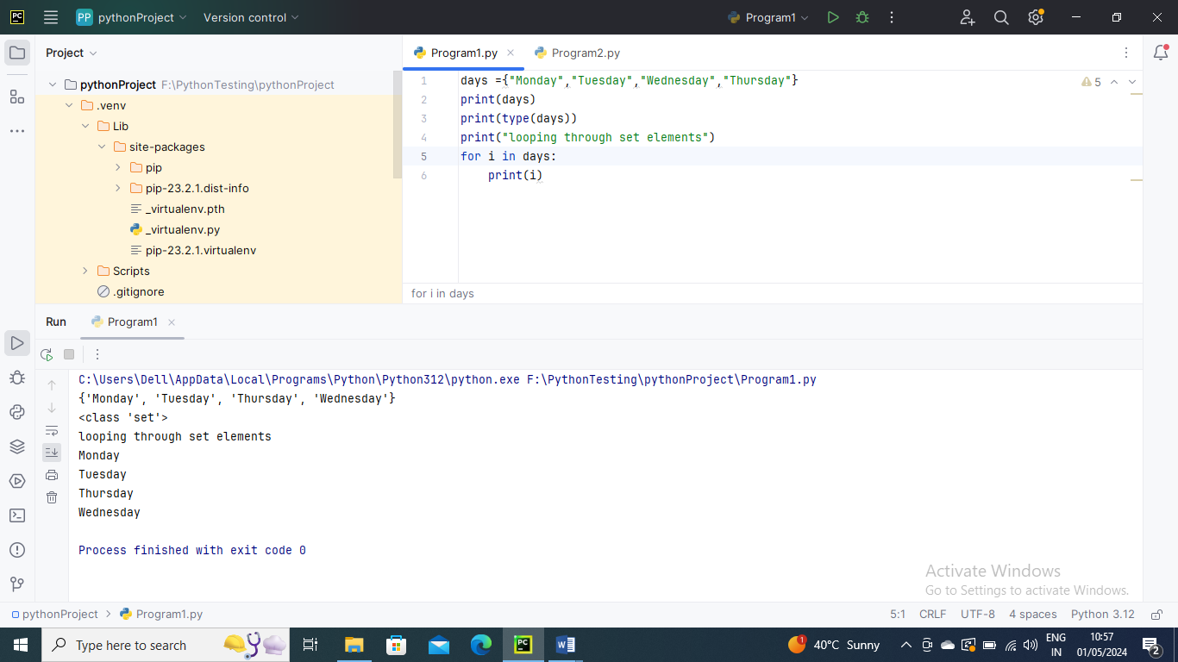

Using set() method

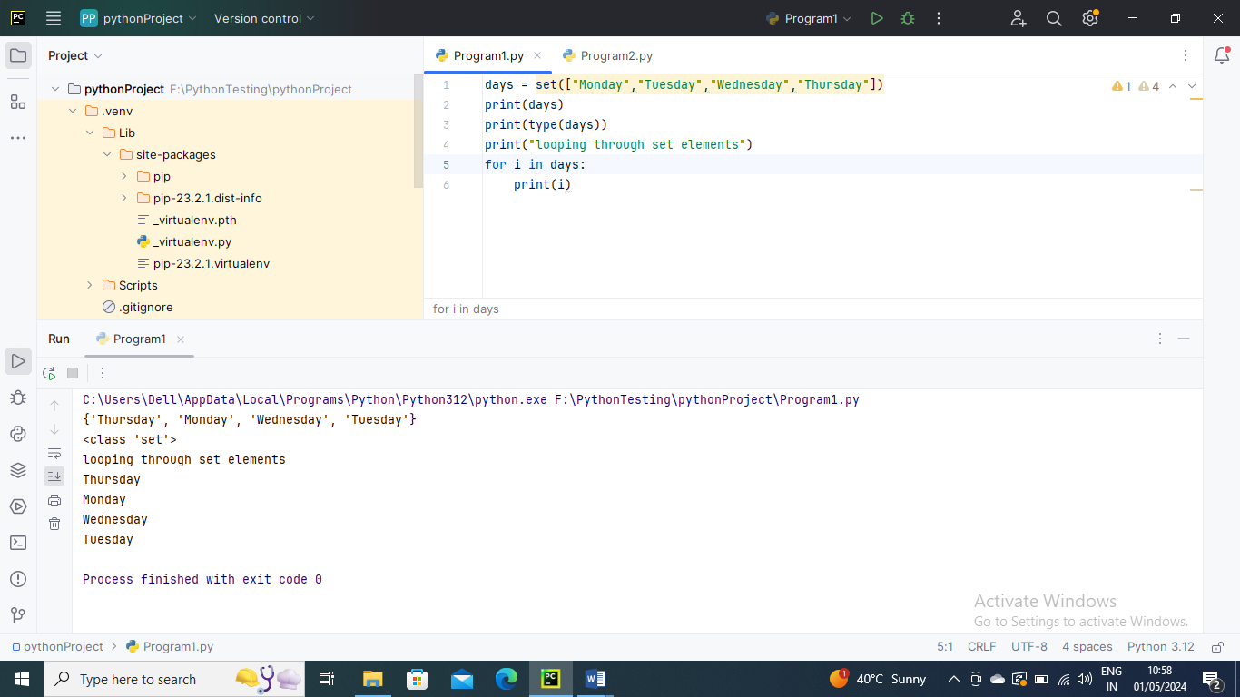

-------------------------

It can contain any type of element such as integer, float, tuple etc. But mutable elements (list, dictionary, set) can’t be a member of set.

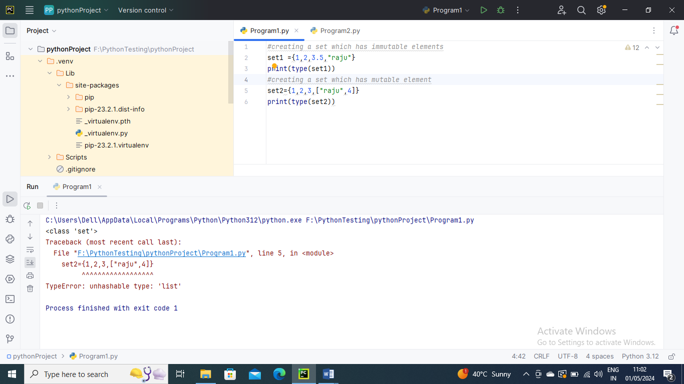

--------------

Adding items to Set

Using add() method

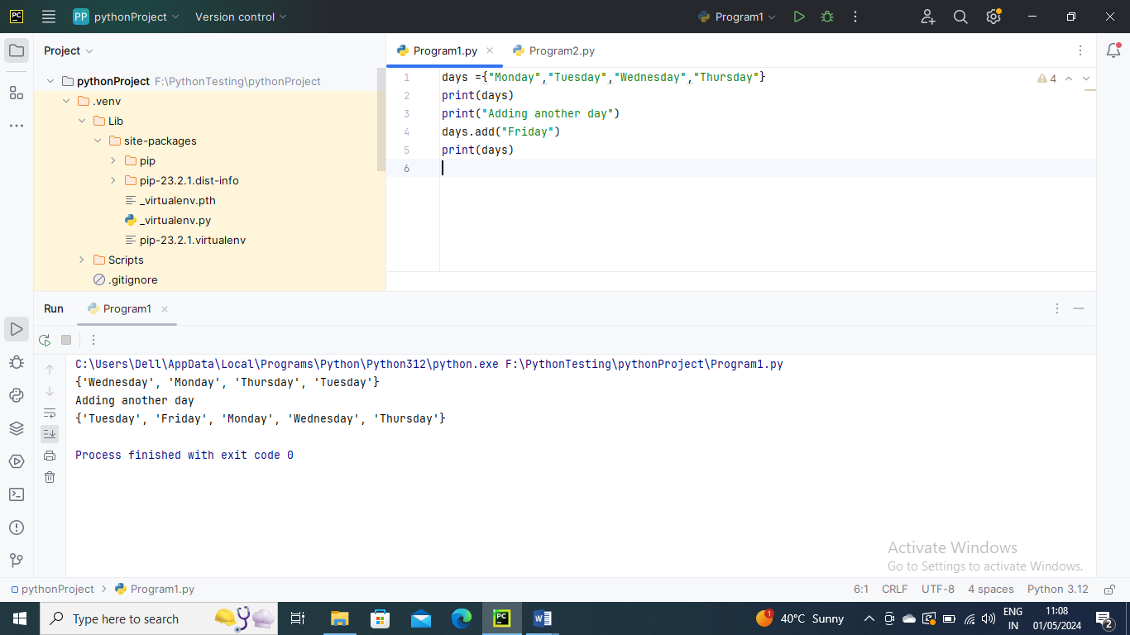

Using update() method

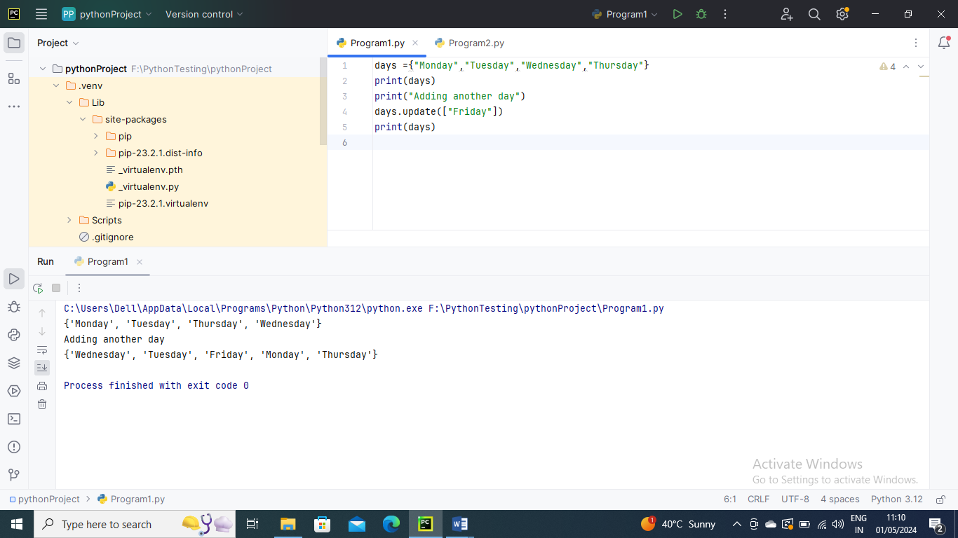

Removing the items from the Set

Using discard method()

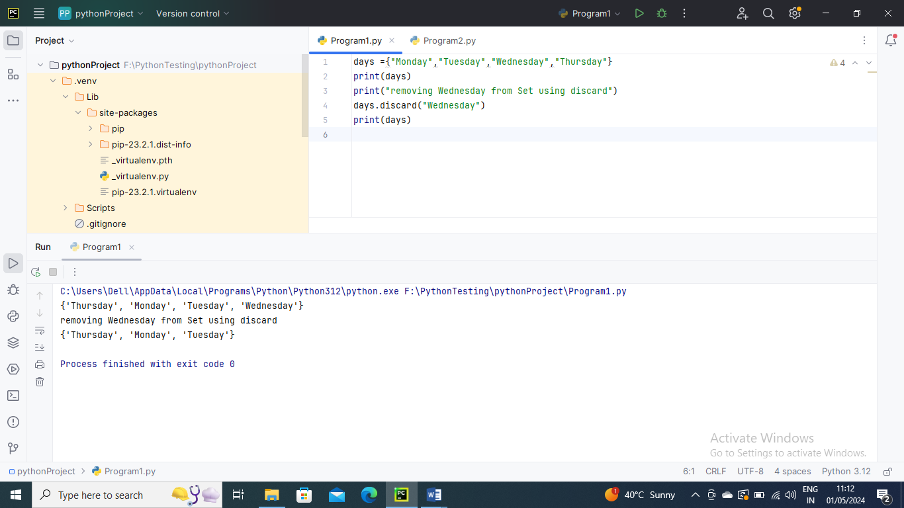

Using remove() method –

